PORTFOLIO OF EVIDENCE

BY Duran Moodley 13016335

Assignment 3

# Problem Statement

## Purpose

The Durban Art Gallery needs an application that has extended functionality. The application does not allow the manager to search, update or delete a painting. Currently, it only records details about that painting such as painting Id, painting name, owner name, cost price. Each painting has a 7 alpha-numeric random ID number. This information gets displayed in a list box. The manager would like all this information to be displayed in a professional report. Furthermore, the application should also store whether or not the painting has been sold and where in the gallery it is displayed. The gallery has been through an extension. This means that there are 4 sections to the gallery (A, B, C, D). This information needs to be updated constantly because every week the location of the paintings in the gallery changes. In addition, if a painting is sold it can be deleted from the system. The search functionality is quite important to the manager. Since the new extension, the gallery is much bigger and consists of a wide range of paintings. Potential buyers don’t have time searching throughout the gallery for that one painting. Therefore, the manager would like the application to accept a name of a particular painting and display its details.

## Functionality

* Add Painting
* Delete Painting
* Search a painting
* Update painting details
* Displays a professional report
* Generate a 7 alpha-numeric random ID number
* Connects to Sql Server database called Durban Art Gallery

## Additional Functionality

* Displays a report of all paintings
* Filters the report using the owner id number.

# Database

## Table Structure

|  |  |  |  |  |
| --- | --- | --- | --- | --- |
| Painting Id | Painting Name | Cost Price | Status | Section |
| AE45678 | Autumn Landscape | R500 | Available | B |
| BE67676 | Almond Tree in blossom | R1500 | Sold | A |
| HE17171 | Child with Orange | R5000 | Available | D |

|  |  |  |  |  |
| --- | --- | --- | --- | --- |
| Owner Id [PK] | Owner Name | Owner Surname | Owner Cell  Number | Painting ID [FK] |
| 12345678222 | George | Dawson | 4567890125 | AE45678 |
| 87654321111 | Mathew | Smith | 3456723451 | BE67676 |
| 11111111111 | Derek | Anderson | 4575434343 | HE17171 |

## ERD Diagram



## Sample of Script File

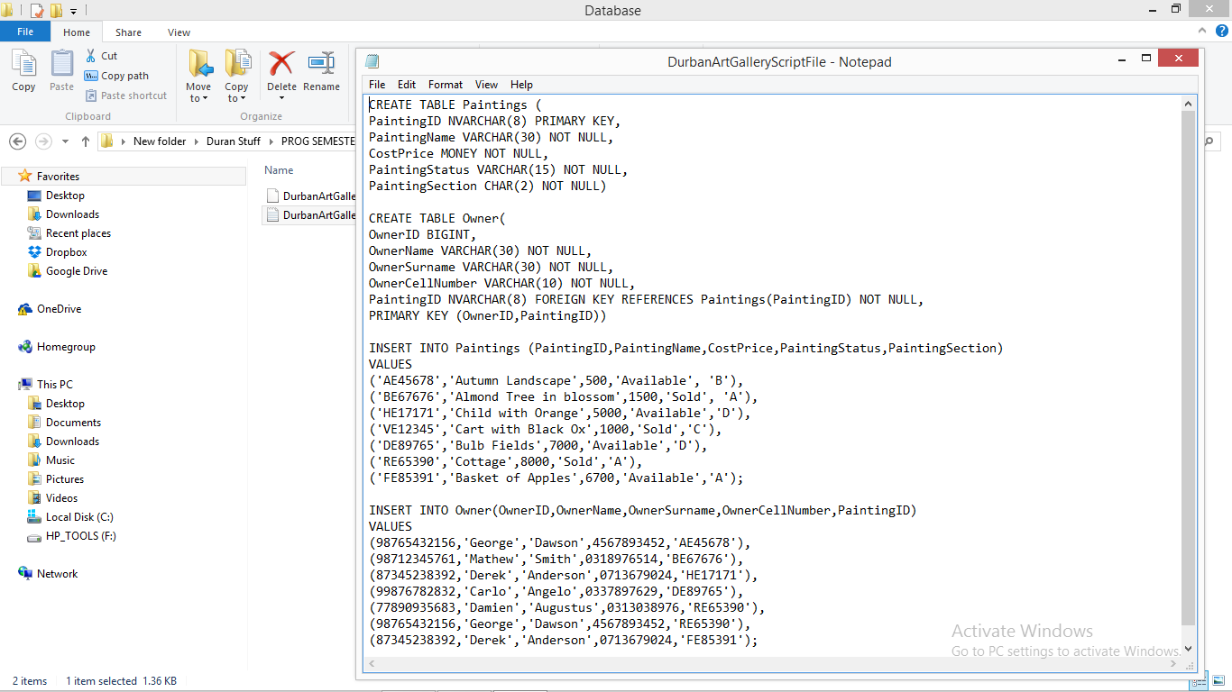

# How the Program works

The program starts with a splash screen followed by a Menu form. The Form contains 2 menu options. In the Actions option there are a number of sub menu. Add Painting, Update painting/Owner, Delete Painting, Search Painting and View report (Paintings or Owners).

Clicking on the Add Painting brings up the add painting form. By hovering the mouse over the painting ID text box, a random id number is generated consisted of 2 random characters and random digits. The then needs to fill in all the relevant information about that painting such has: painting Name, painting selling, the painting status (Available/Unavailable) and painting section. Once the user clicks submit, that information is saved to the Paintings table in the database and the add artist form automatically gets displayed. If the Painting has an artist, the user needs to enter details about that artists which are: Artist id number, artist name, artist surname and artist cell phone number. Clicking submit will send that information to the owner table in the database. The user can then decide if they want to add another painting or go back to the main menu.

Clicking on Update Painting will display the update painting form. A list box will display all the painting id numbers. By selecting an id number and clicking search, the user will be shown all the details of that particular painting shown in text boxes. The user can then change any detail of that painting and click Update. This will change the data of that painting in the database. The same process is used in the Update owner, however the forms are different.

Clicking on the Delete option in the menu form will bring up the delete painting form. The user has to select a painting id number by clicking on the drop down arrow in the combo box. Once selected the user can click delete. Deleting the painting will automatically delete the owner associated with it.

Clicking on the search on the menu form, will bring up the search painting form. The user will need to enter the specific painting name. Clicking search will show the details of that painting in a grid view only if that painting is found.

Clicking on view report, will display a customized professional report of all the painting in the Gallery. In addition, the user can display all paintings owned by a specific artist by clicking on the owner report. The user needs to select the id number of the artist from the drop down list on the form. Clicking generate will display all the paintings that is owned by that artist.

# Screenshots

**Splash Screen** – starts the application

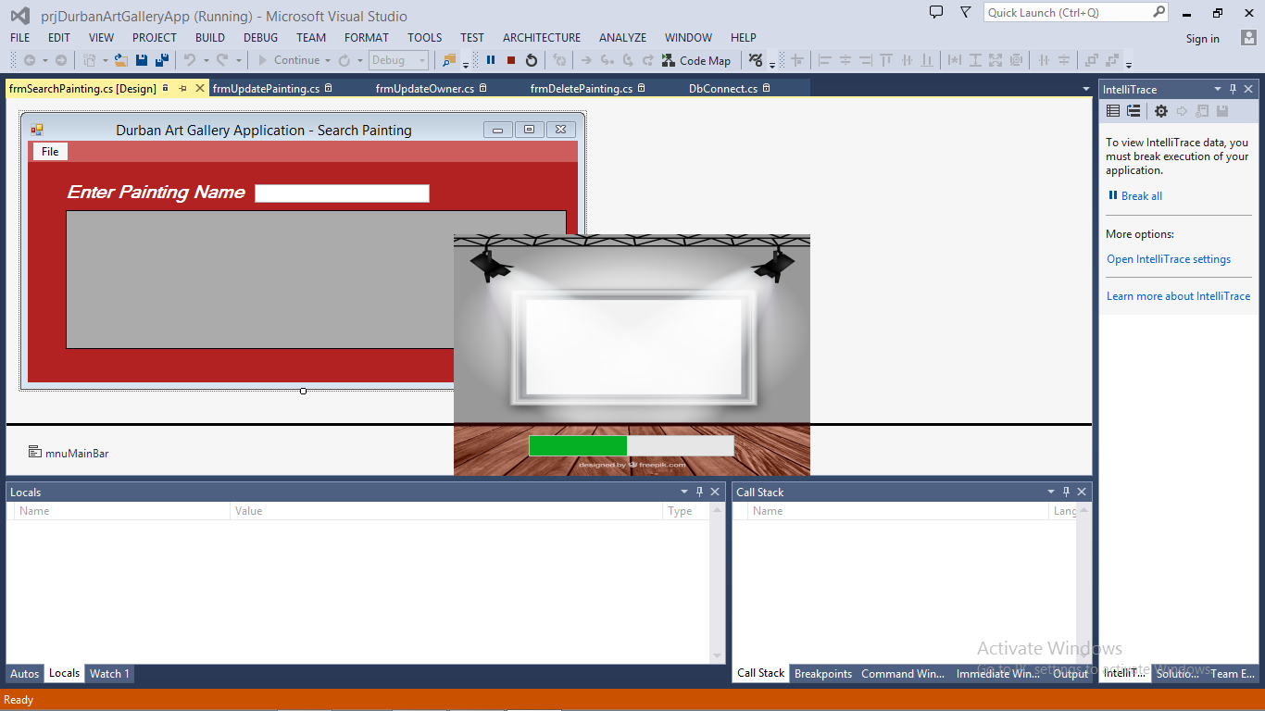

**Menu Form –** This provides the user with a list of options that can be selected.

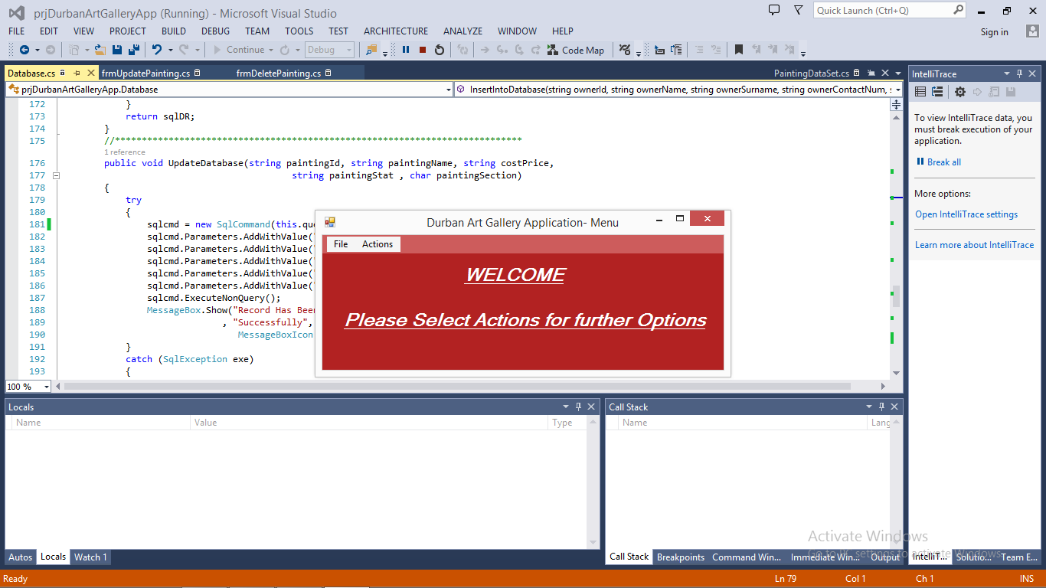

These are the options that can be selected by the user

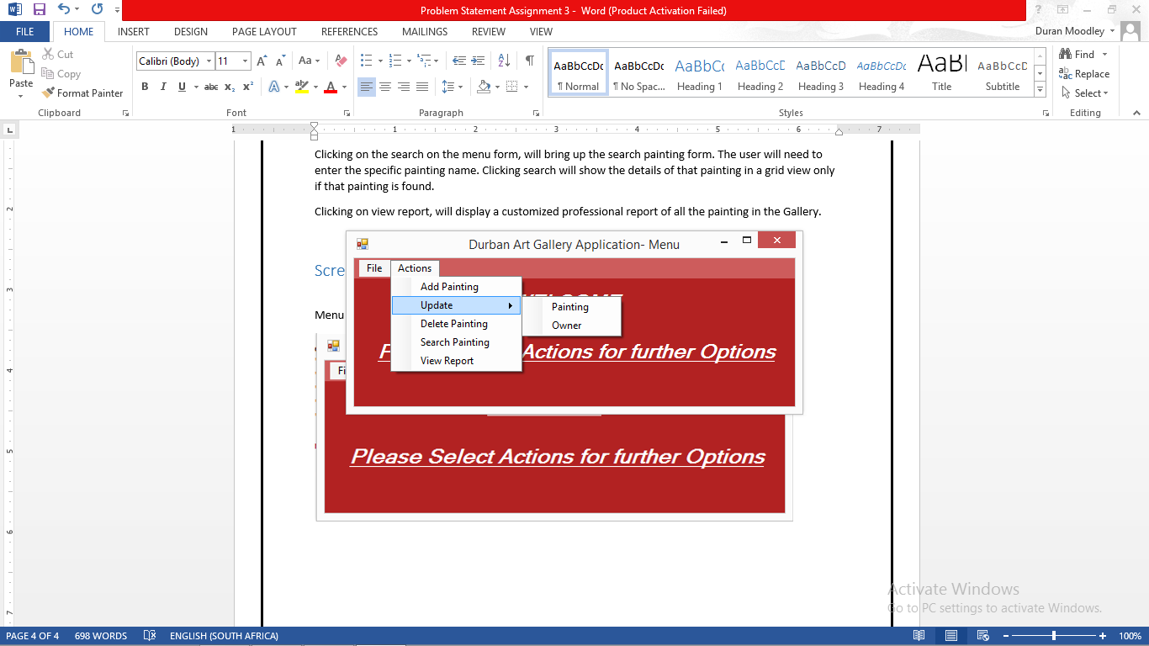

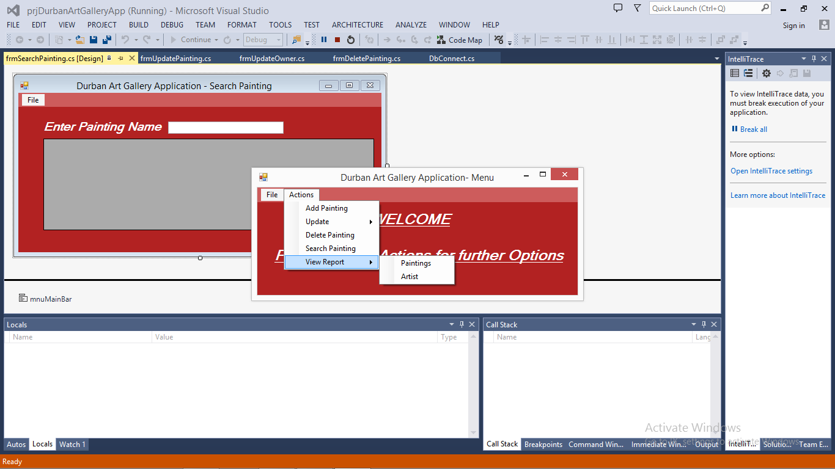

**Add Painting form –** Allow the user to enter details about the painting. Clicking next will send the painting details to database

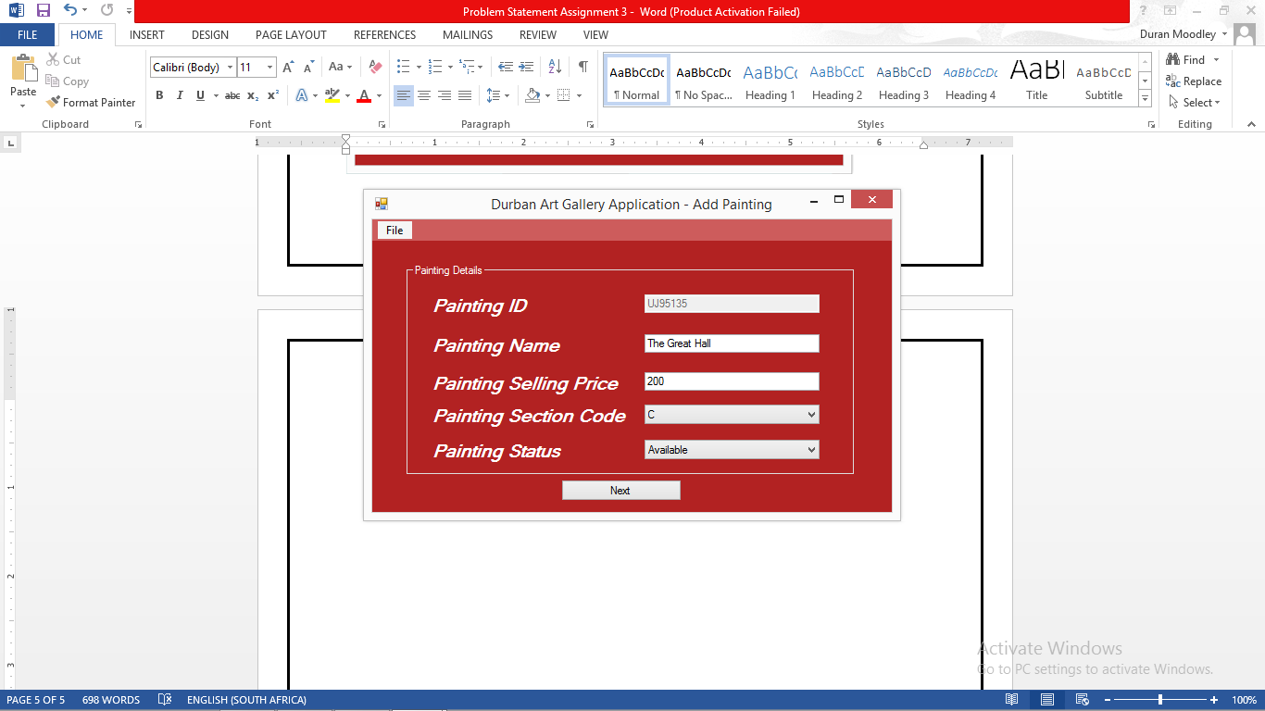

Confirmations message, giving feedback to the user that the painting information has been saved

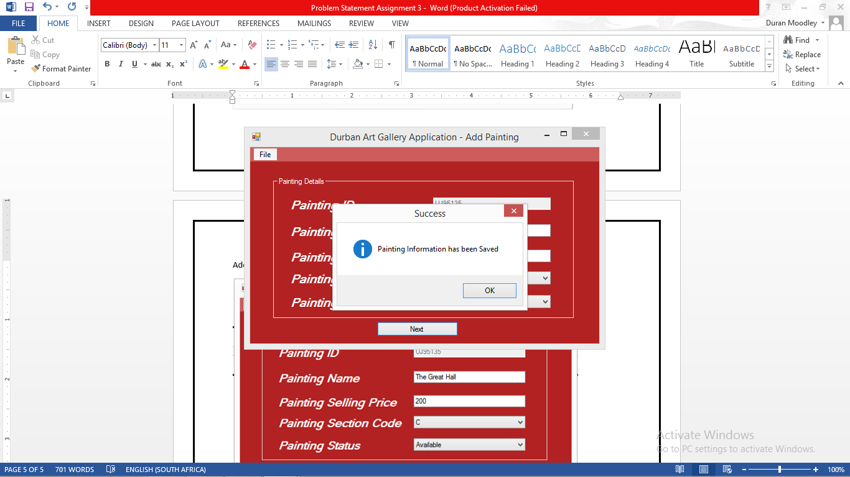

**Add Artist Form –** After submitting painting details. The user must enter in the details relating to the Art of the painting

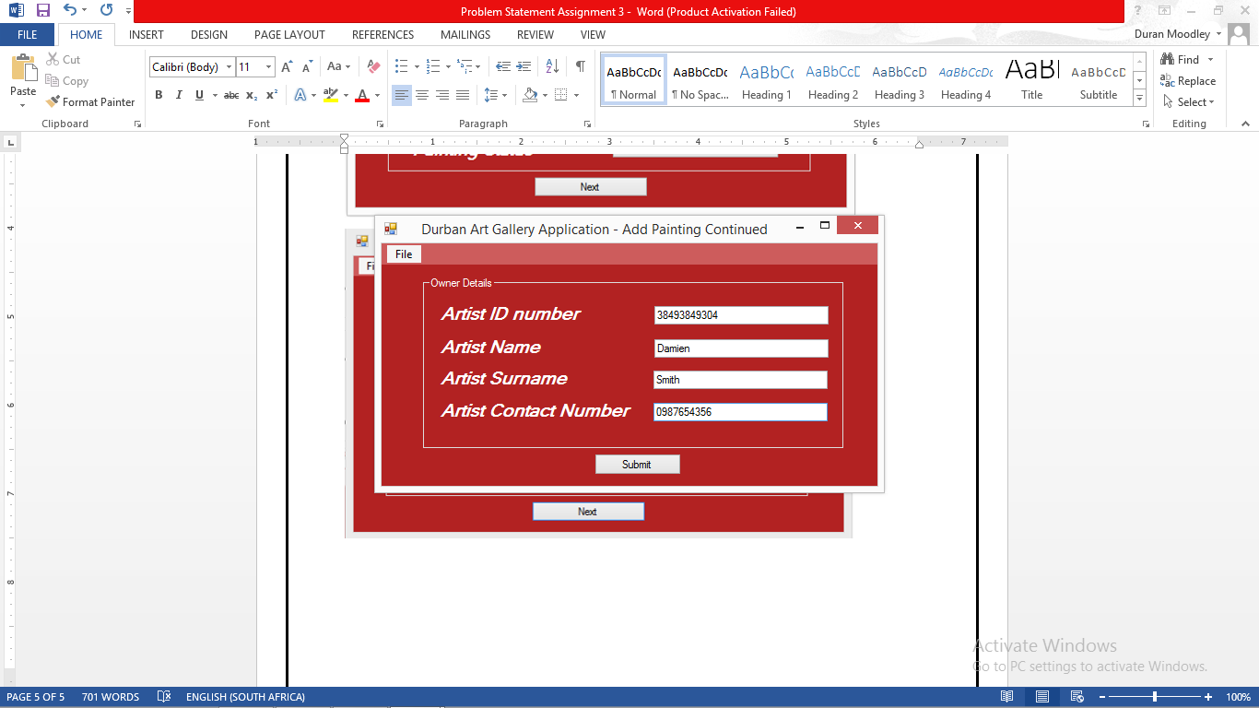

Confirmation message, giving feedback to the user that the information has been saved

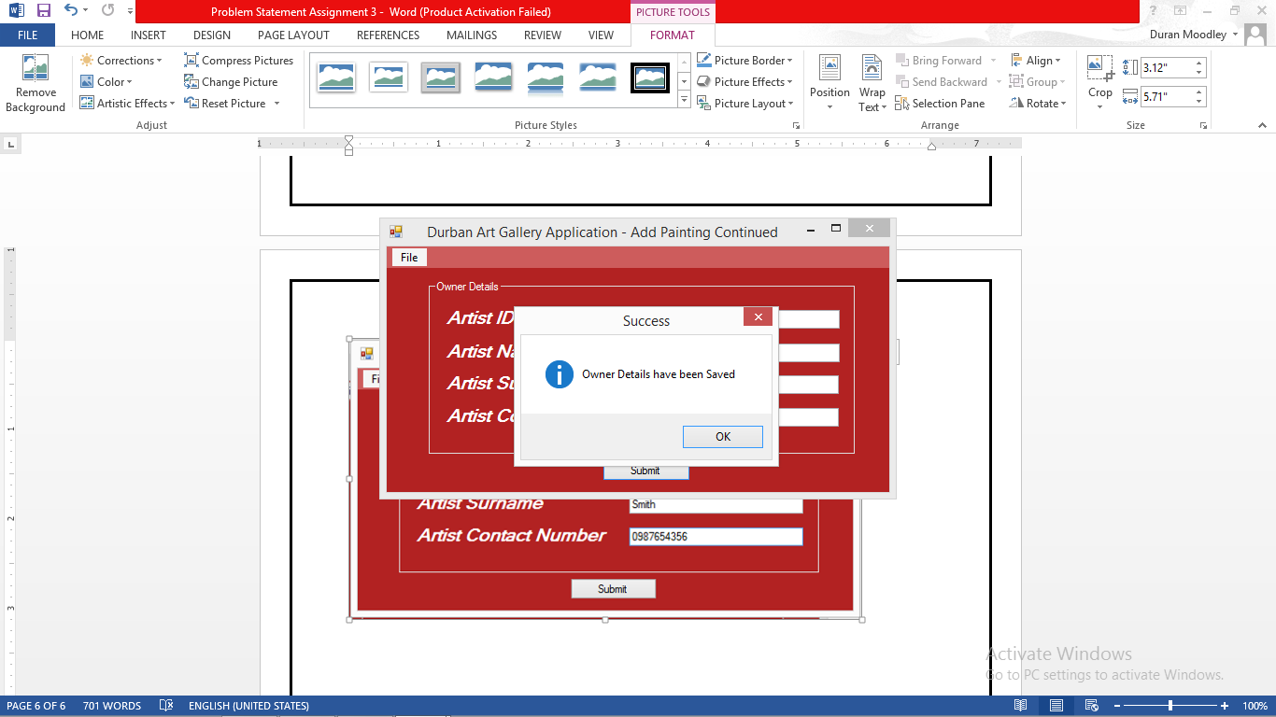

**Update Painting form –** Allows the user to select an painting to be updated by selecting the list of painting id numbers.

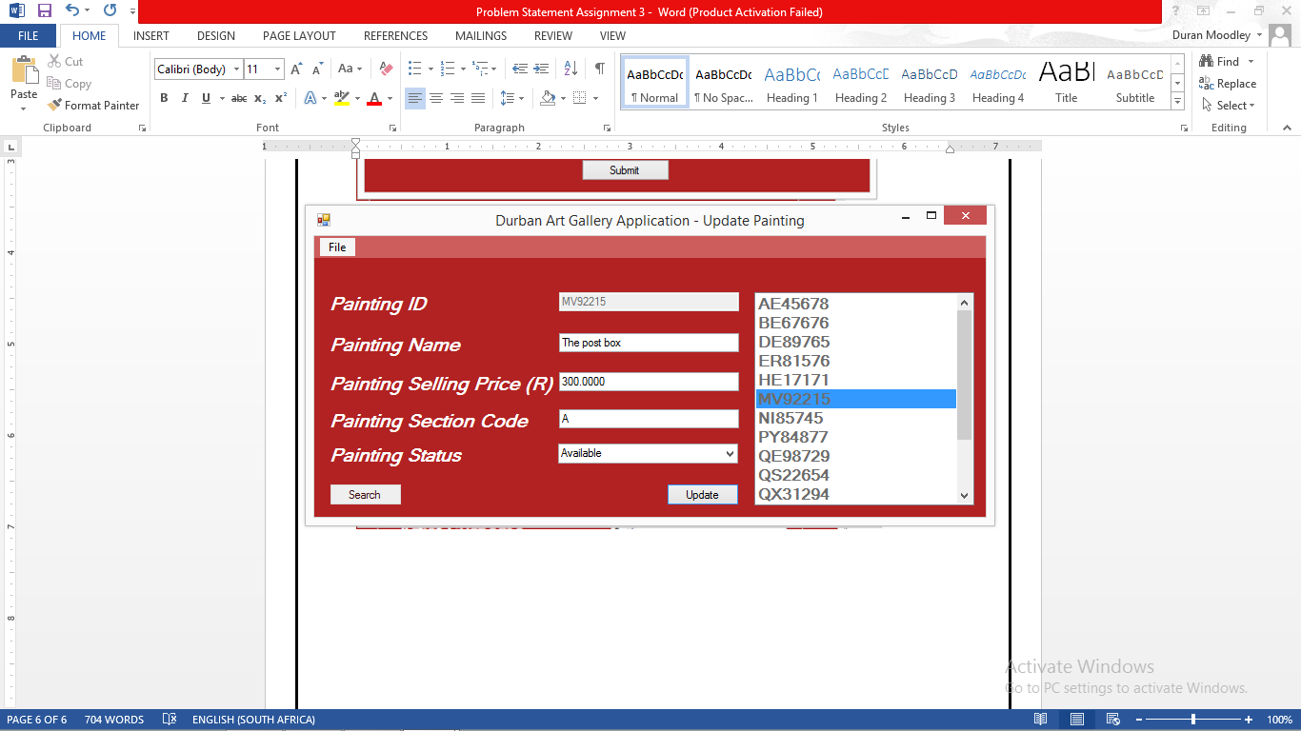

Confirmation message, feedback indicating that the painting has been updated

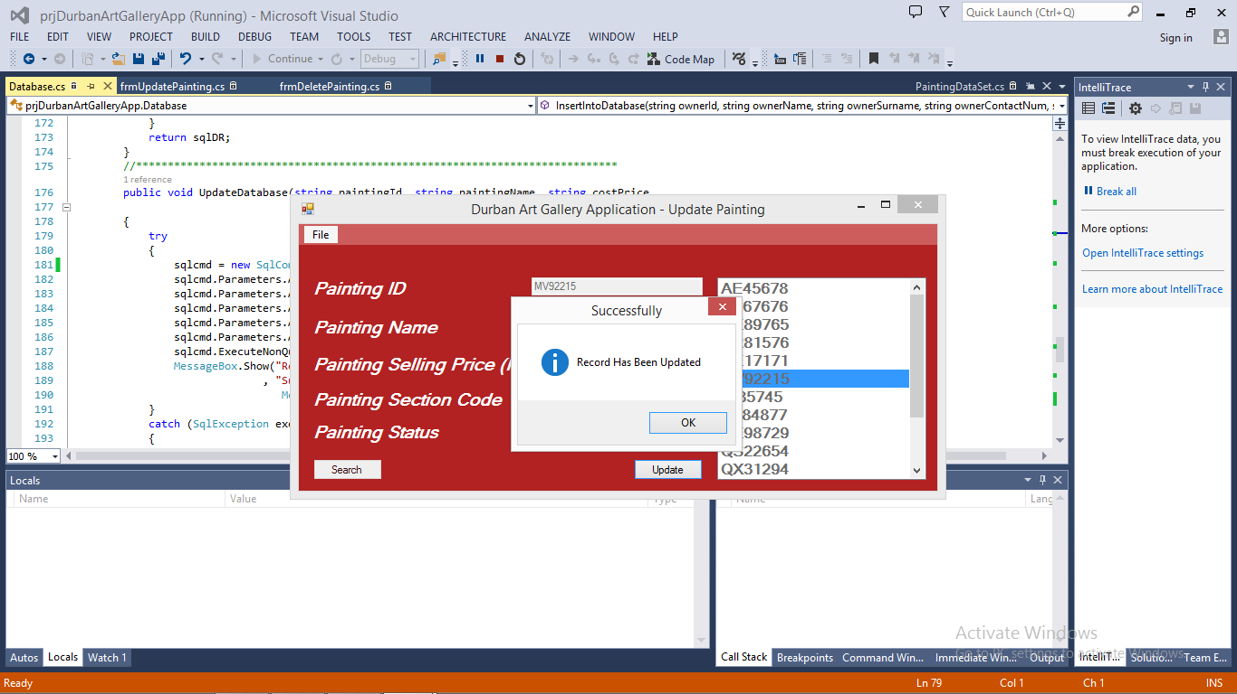

**Update Owner** – Allows the user to update an owner by selecting the appropriate owner id in the drop down list.

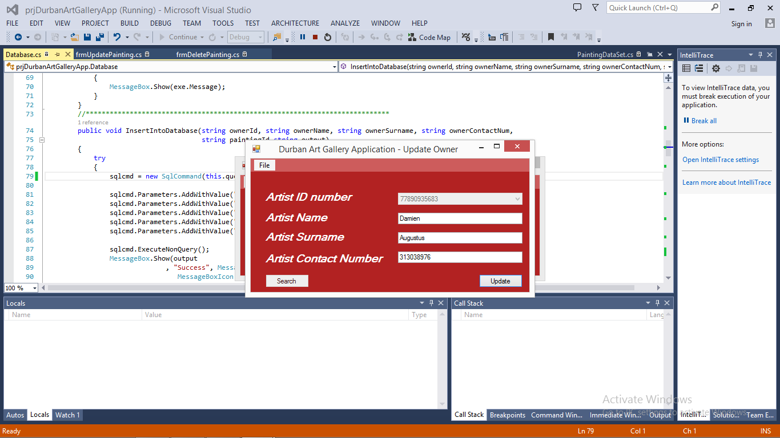

Confirmation message, feedback indicating that the owner has been updated

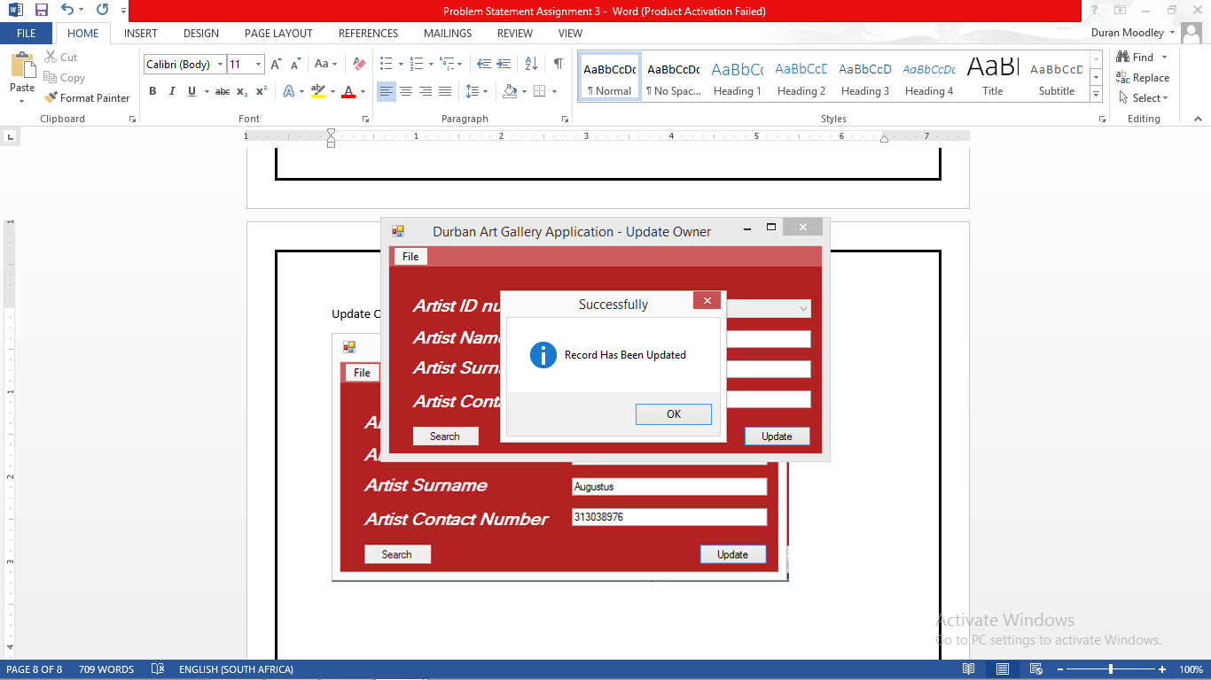

**Delete Painting Form** – select a painting from the drop down list. Clicking delete will delete it

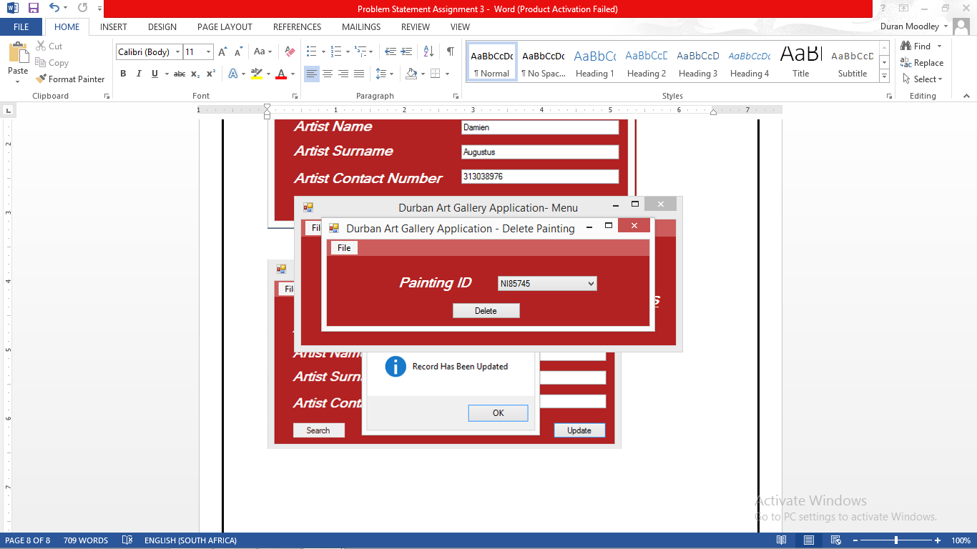

Confirmation message, feedback indicating that the painting has been deleted

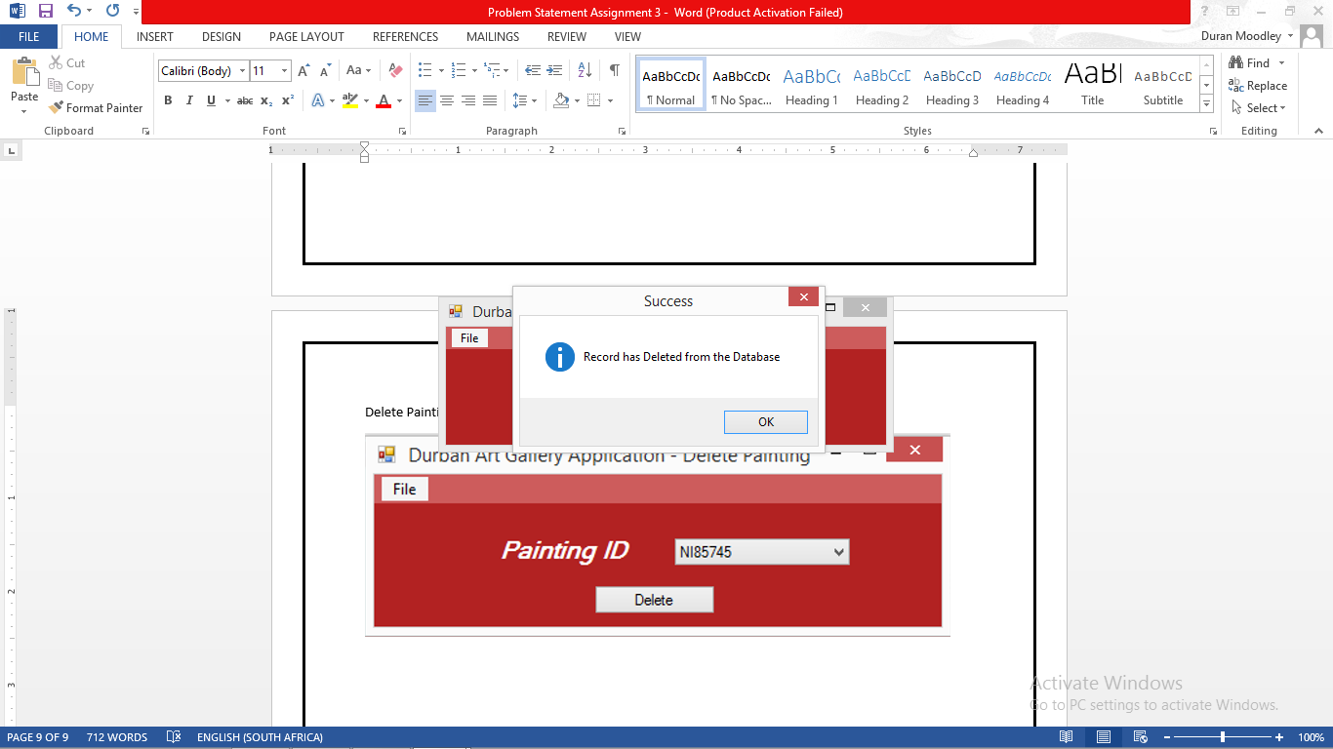

**Search Form –** allows the user to enter in the name of painting. If the painting is found it will display the relevant information about that painting in the data grid view.

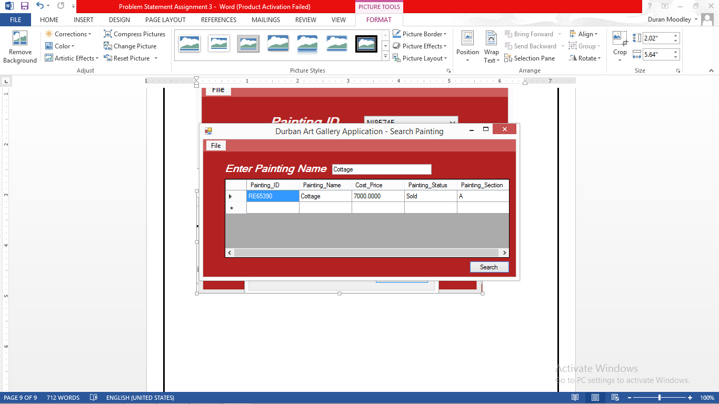

**Report Form –** Displays all details relating to the painting

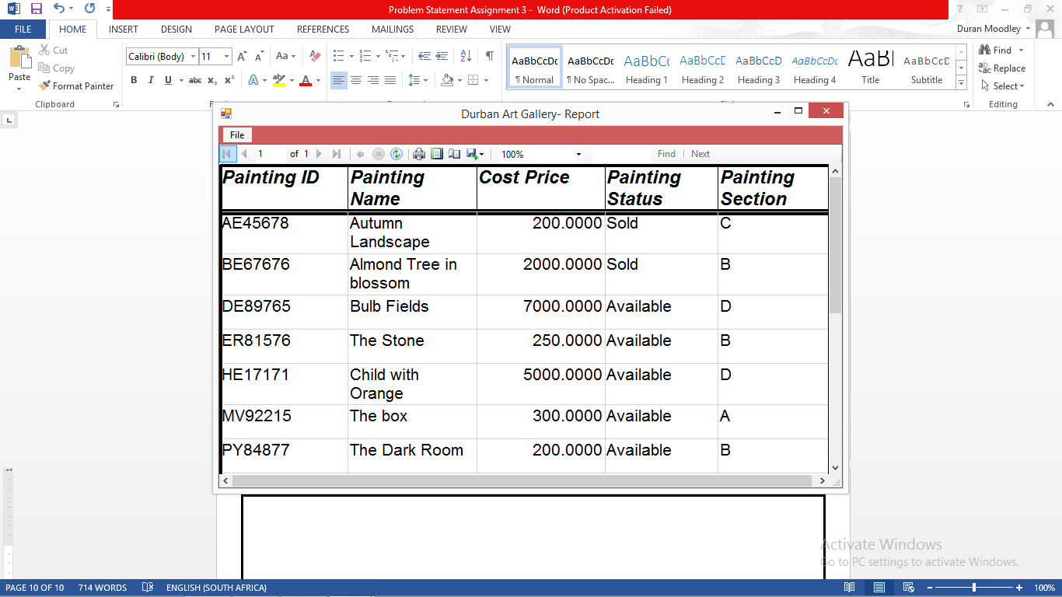

**View Artist Report form** – The user can select the id number from the drop down list. Clicking generate will display all paintings owned by that artist.

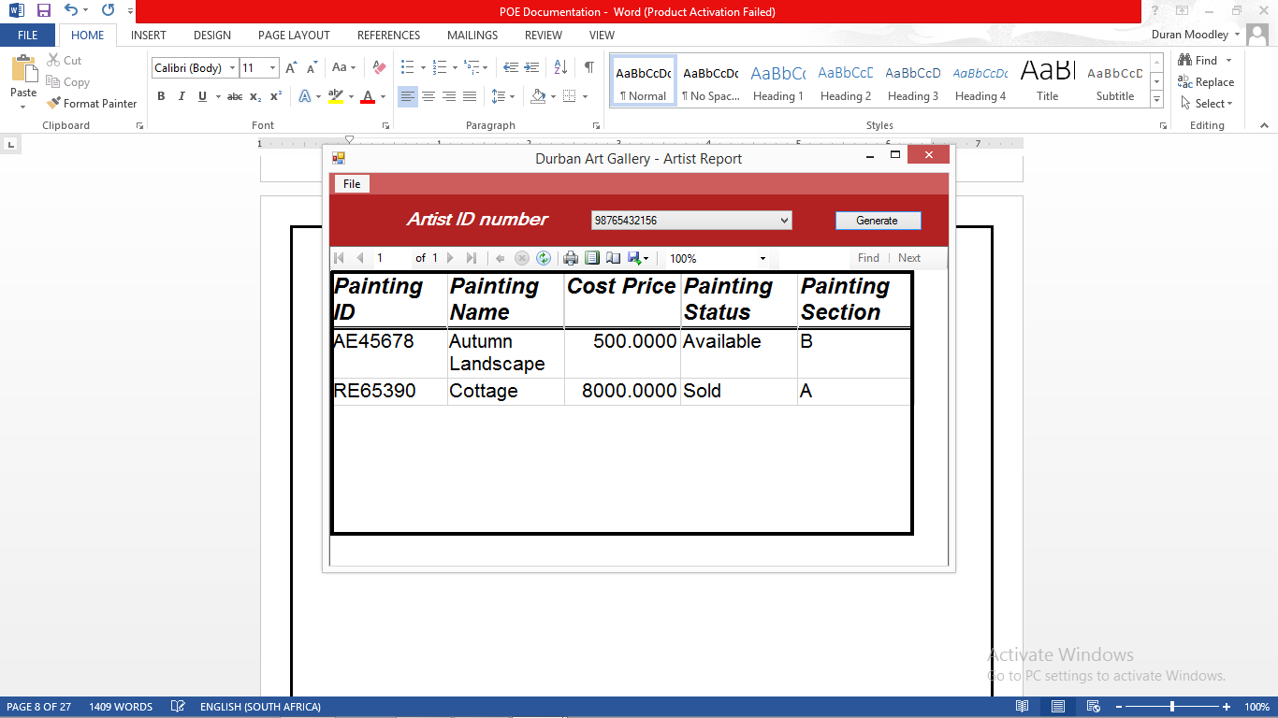

# Feedback on Client Meeting

On the 7th of October, I visited the African Art Gallery at approximately 11 am. This meeting was definitely a huge learning experience. I showed the current progress of my program to the Director of the Art Gallery Magdalene Reddy. Her feedback was positive and mentioned that I was on the right track thus far. However, she did mention that there should be some changes that will increase the usability of the program. One of these changes is related to the update painting. The client mentioned that finding the id numbers of a specific painting is tedious and cumbersome. She therefore thought that it would be a good idea to have all the painting id numbers displayed on the screen. Allowing the user to select it. Taking this into account, I therefore decided to add the list box and fill the list box with painting ids. The user can then select the painting id and update it. Other changes that the client requested are the following:

* Change Owner Labels to Artist (Update and Add Owner forms)
* Change Cost price to Selling Price( Add painting form)
* Insert a professional report of all the paintings only

Lastly, visiting the Art gallery got me thinking of additional features which I can definitely add on to the program in version 2 (POE).

# 

# Flow Chart







# Class Diagrams

# Lecturer Feedback and Corrections

|  |  |
| --- | --- |
| Lecturer Feedback | Corrections Made |
| Db add more inserts | More Inserts where added |
| Rename database class to db connect | Database class has been renamed |
| Rename label1 in add painting form | Label1 has been renamed to painting status |
| Painting and Owner has an empty constructor. Remove it. | Constructors have been removed. |
| SQL Security issues. | Sql code adjusted to prevent security problems |
| Remove underscores from table field names | Underscores have been removed from table names |
| Run code analysis – found 7 cloned code. Use methods and classes to prevent this. | Not fixed. |
| Search for parts of a name using like clause | The like clause has been added |
| View report does not work. Error ”failed to enable constraint” | Could not locate the error. Report works. Refer to screenshots above. |

# Enhancements

* A Splash screen was added to the program.
* A new data set was added. This filters results of a specific owner and contains data related to that owner.
* A new report has been added. This report allows the user to filter results based on an artist. If the User would like to know all the paintings that an artist owns. The user can simply select the artist from the drop down list. Clicking generate will display a report of all the paintings owned by that artist.